Calculus Summary + formuleblad

WEEK 1

**Completing the square**

X2-4x+3=(x-2)2-1

(x-2)2=1

X=3

**ABC-formula**

X = (-b±sqrt(b2-4*a*c))/2a

**3rd degree polynomial (keep repeating this if higher degree polynomial until 2 remains)**

1. Guess first zero
2. 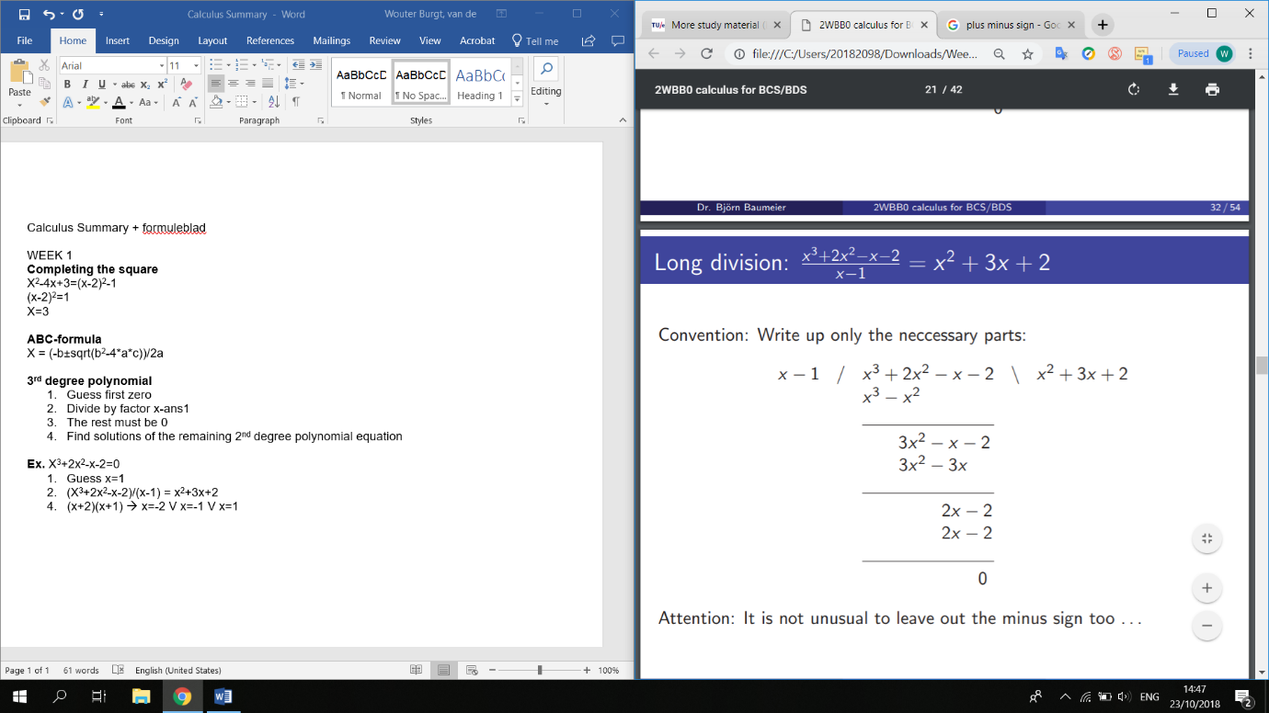Divide by factor x-ans1
3. The rest must be 0
4. Find solutions of the remaining 2nd degree polynomial equation

**Ex.** X3+2x2-x-2=0

1. Guess x=1
2. (X3+2x2-x-2)/(x-1) = x2+3x+2 (see right)

4. (x+2)(x+1) 🡪 x=-2 V x=-1 V x=1

**Special forms**

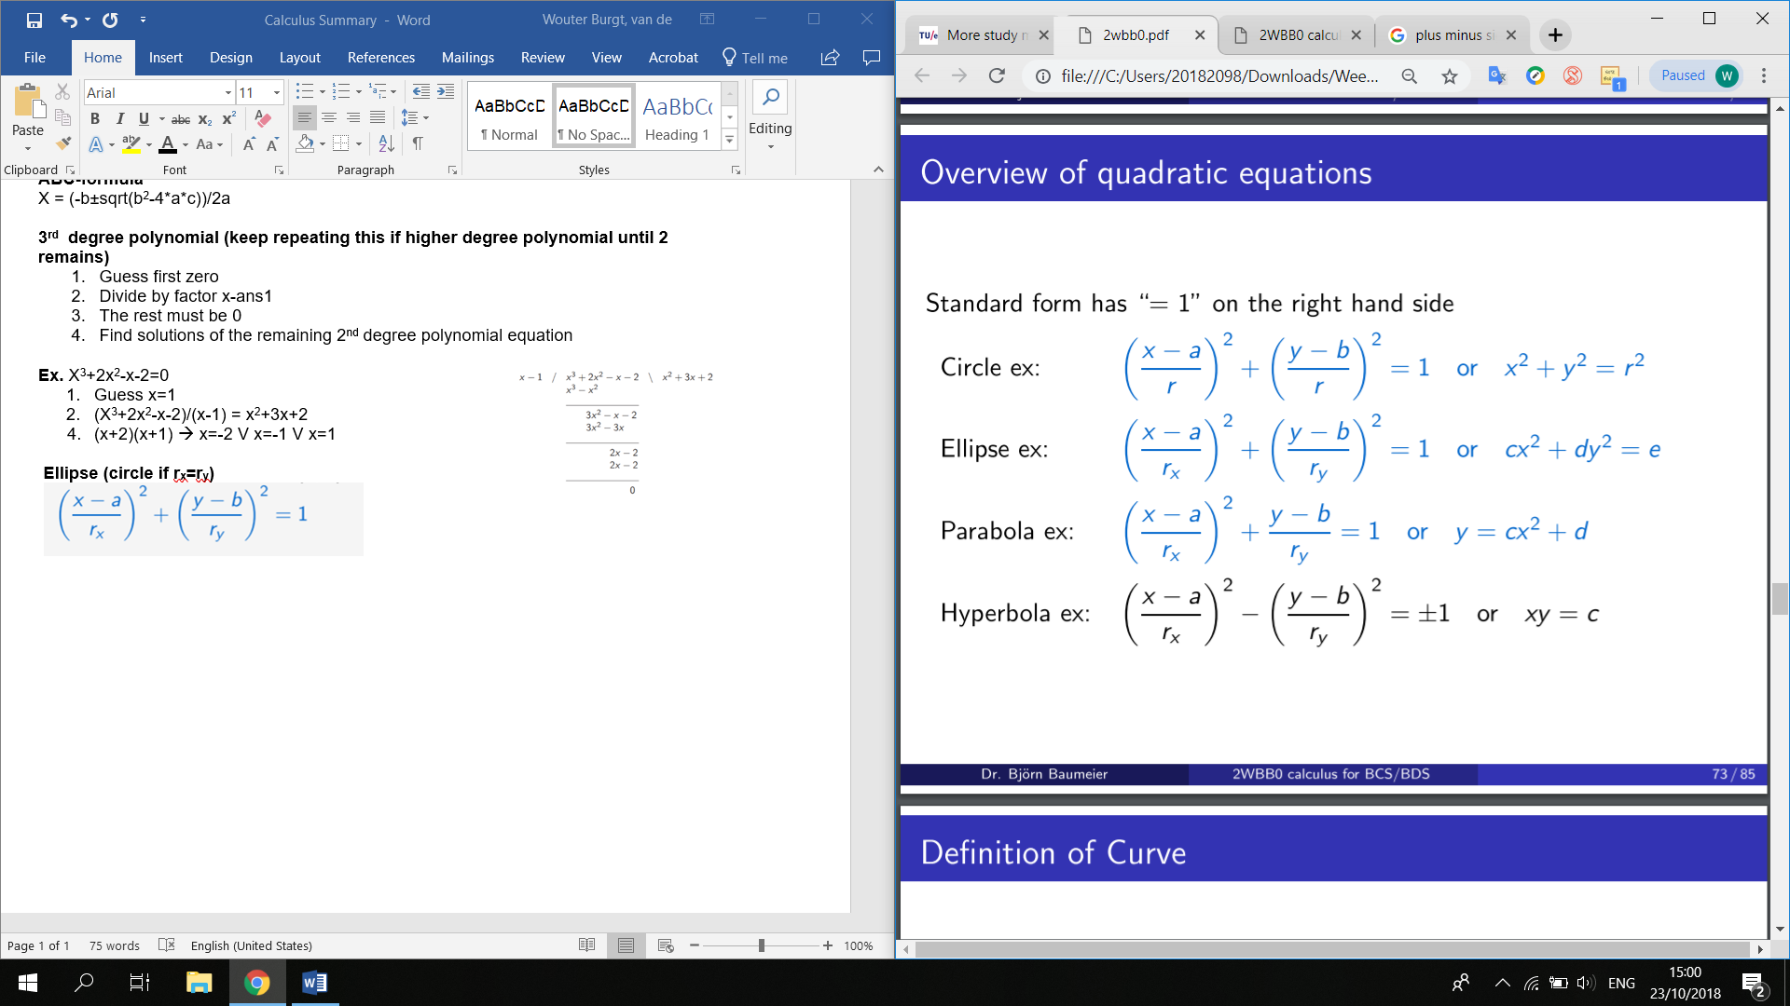

**Symmetry**

F(x) = f(-x) for all x, f is mirrored at the y-axis, even function

F(x) = -f(-x) for all x, f Is mirrored at the x-axis, odd function

WEEK 2

**Goniometrische vergelijkingen**

Sin(-x) = -sin(x)

Cos(-x) = cos(x)

Tan(-x) = -tan(x)

Sin2(x)+cos2(x) = 1

Sin(x+y) = sin(x)cos(y) + cos(x)sin(y)

Cos(x+y) = cos(x)cox(y) – sin(x)(siny)

Sin(alfa)/a = sin(beta)/b

A2 = b2 + c2 – 2bccos(alfa)

**Vectors**

Orthogonal (perpendicular) if a*b=0 (a1*b1+a2*b2 in R2, a1*b1+a2*b2+a3*b3 in R3)

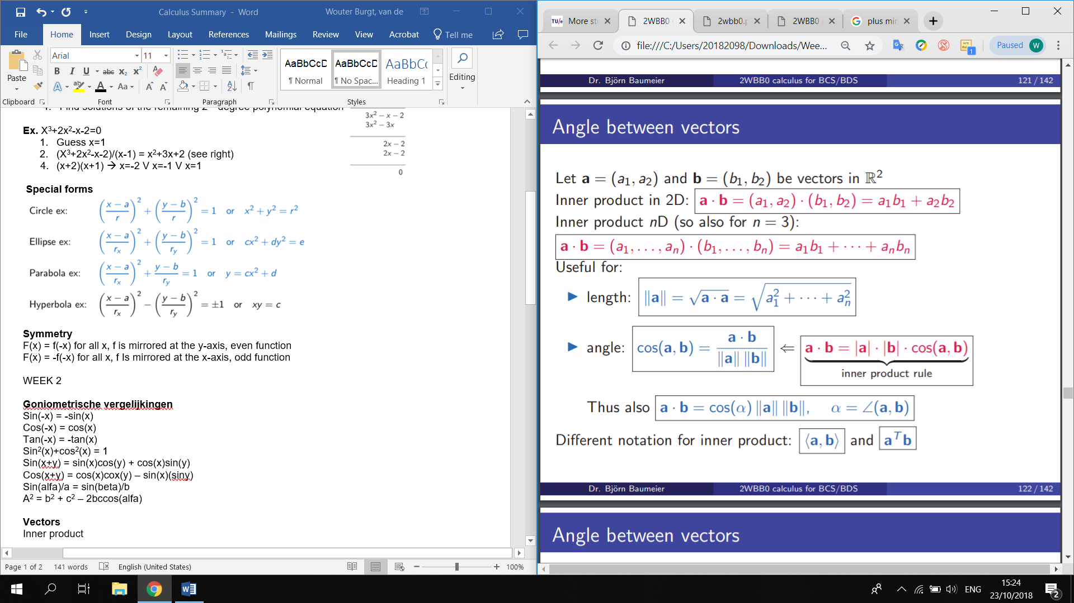Inner product (also used to calculate angles):

**Planes**

**Ex.** x-y+z=1

z = λ and y = μ

so x = 1-λ + μ

yields

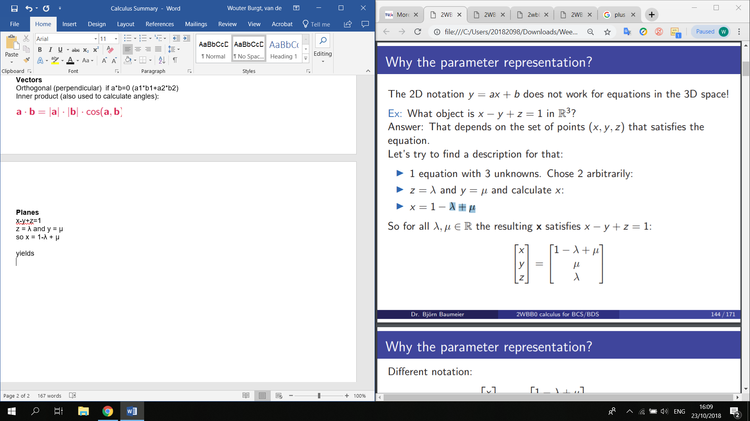

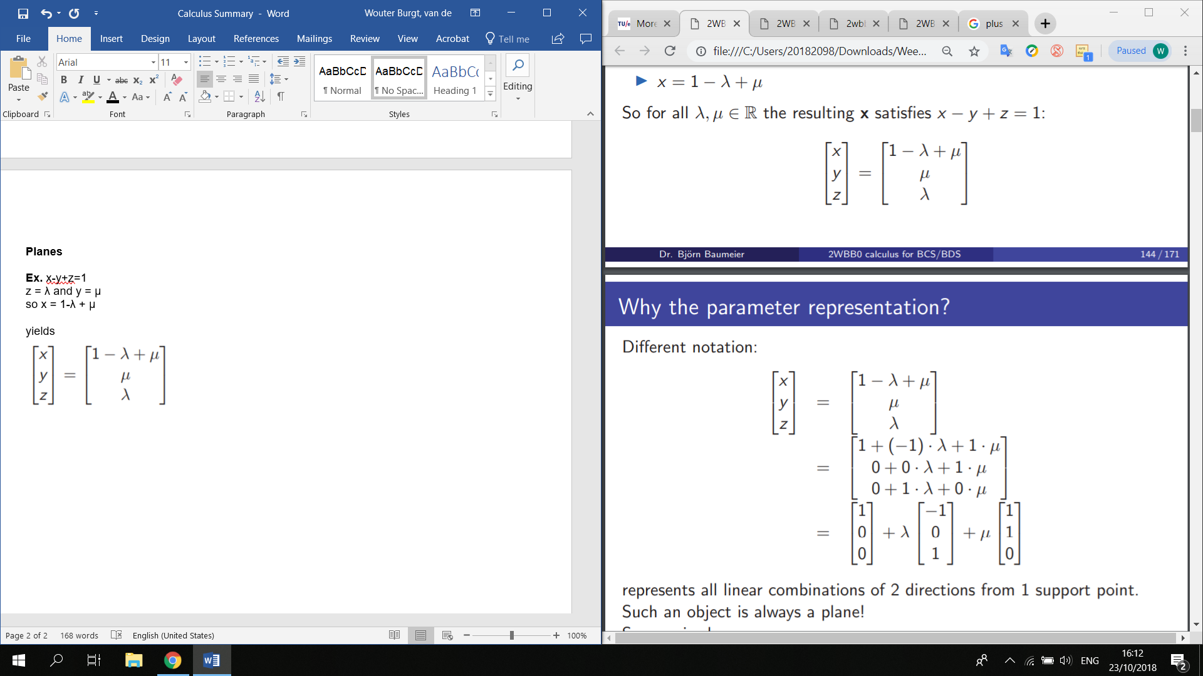

If you have/create 3 points that fulfil the equation

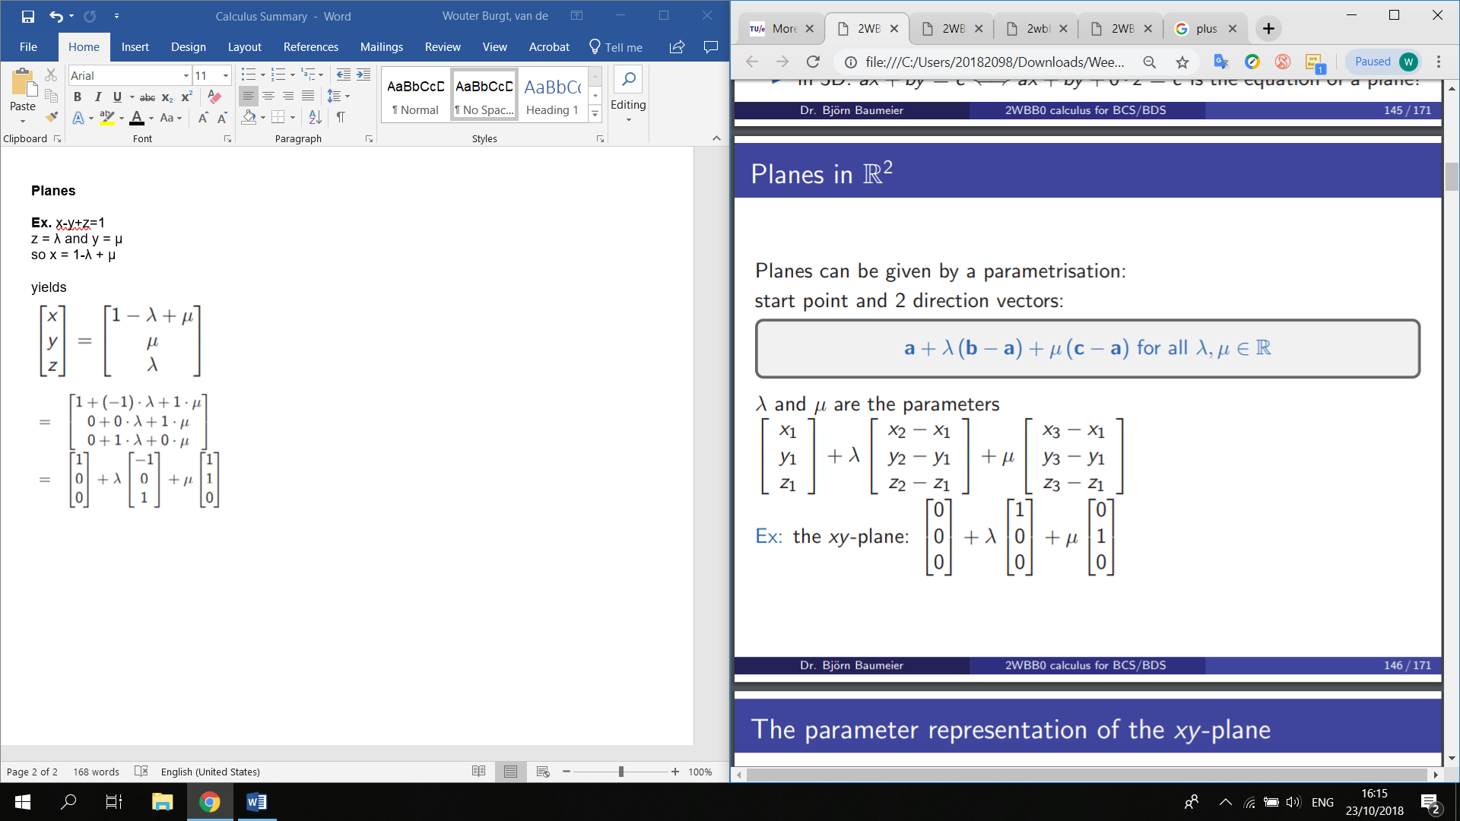

**Cross product**

Cross product is orthogonal to the 2 vectors v and w

Length is the same as the surface of a parallelogram formed by v and w

Also used to calculate the normal vector on a plane

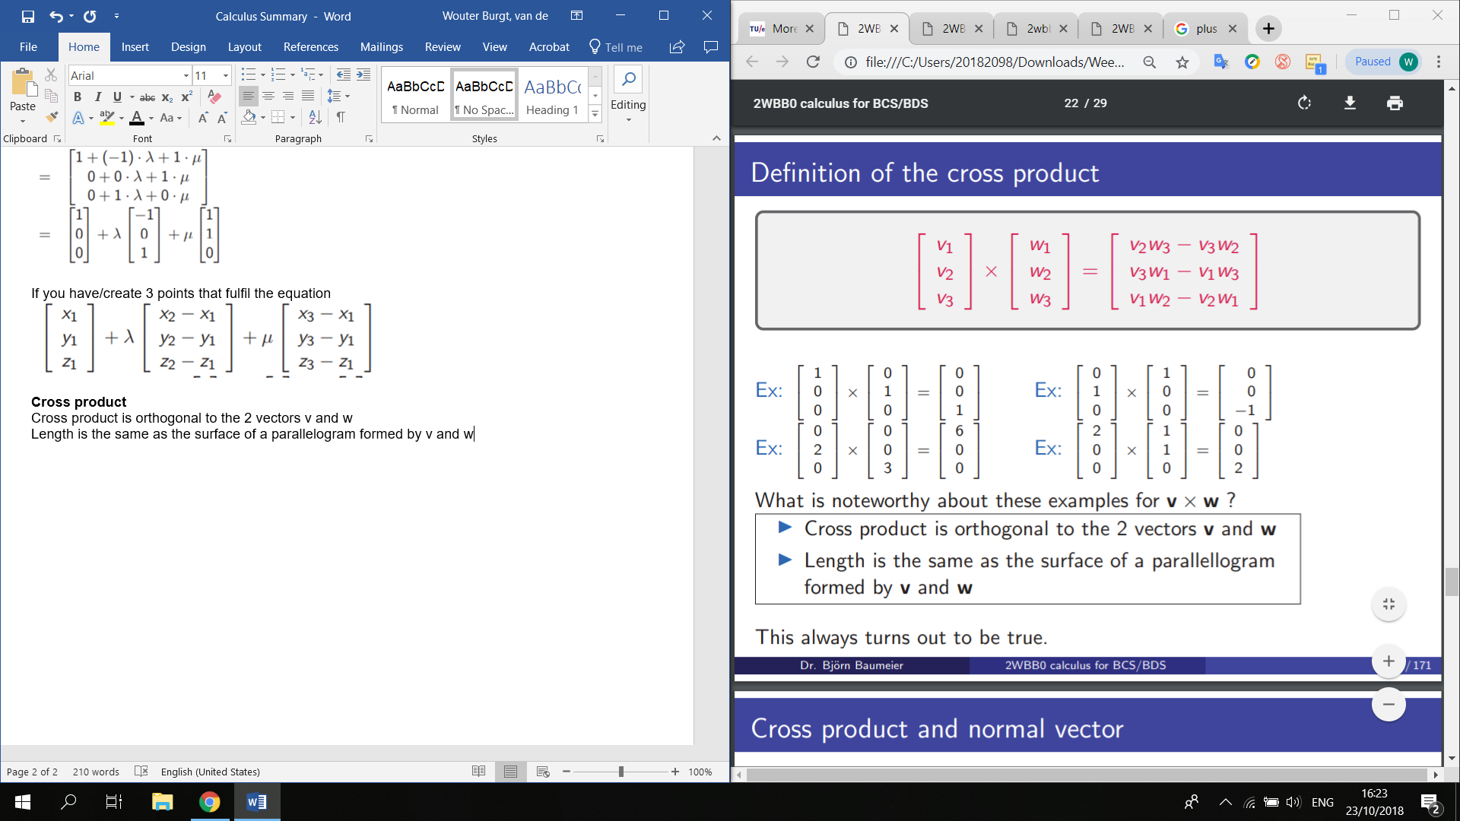

**Distance of a point to a plane**

1. Set up the equation for the line through point orthogonal to plane.
2. Calculate the intersection point of the line with the plane.
3. Calculate distance between point and the intersection point

Or cheat and use this:

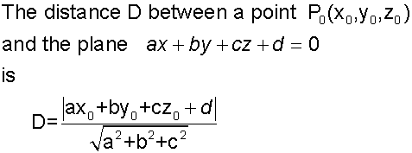

**Surface of a triangle in R 3**

Triangle (a,b,c), (d,e,f), (g,h,i)

1. Calculate cross product (above) of (d,e,f)-(a,b,c) and (g,h,i)-(a,b,c)
2. Surface = ½ * length of this vector

Can be used in R2 using (c,d,0)-(a,b,0) etc.

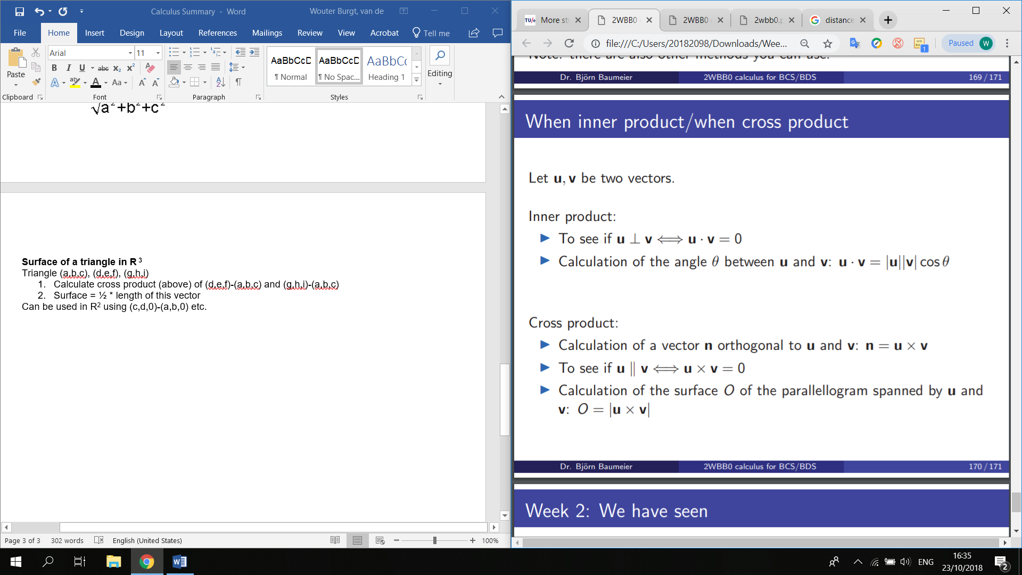

WEEK 3

**Limits special cases:**

If (NOTZERO/ZERO){

Factorize the denominator

}

Else if (ZERO/ZERO || INFINITE/INFINITE){

L’hopital, limit p(x)/q(x) = limit p’(x)

}

**Derivatives**

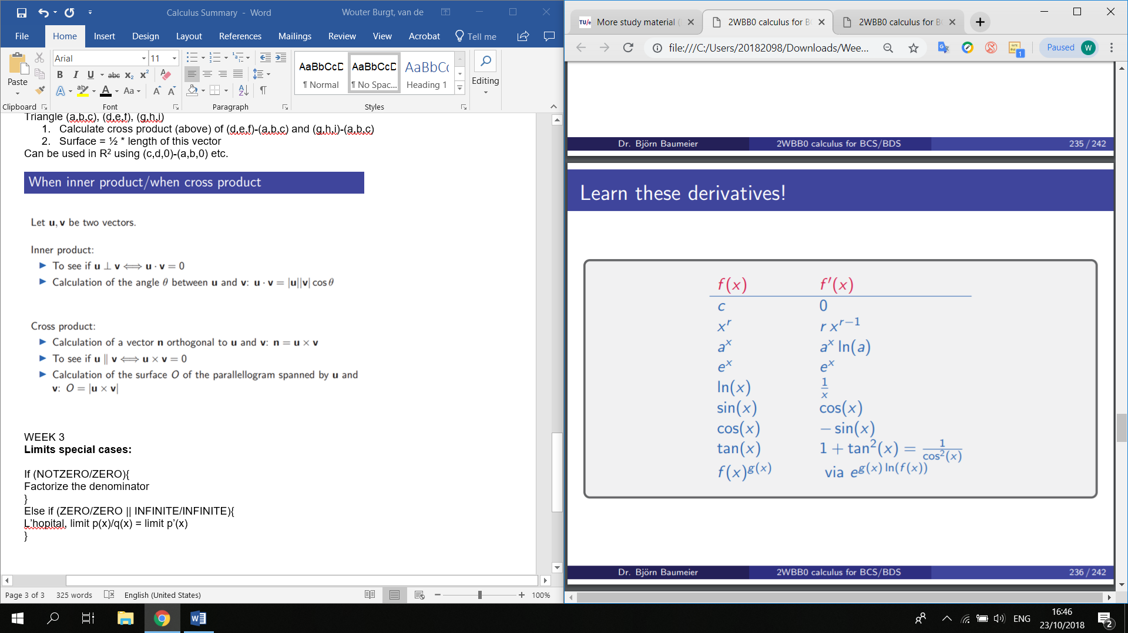

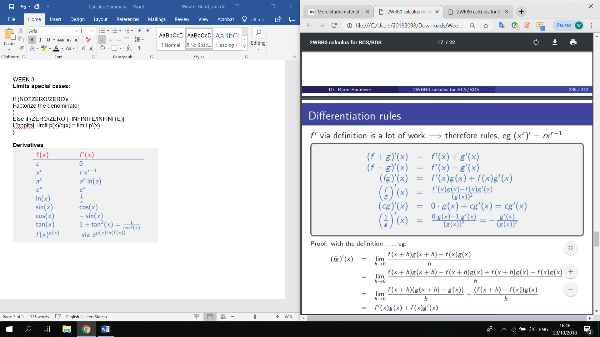

WEEK 4

afgeleide inverse is 1 gedeeld door afgeleide normale functie

(f-1)’(y) = 1/f’(x)

Hoofdletters geven sinusoïden aan op eerste domein

Sin(x) = sin(x) and Tan(x) = tan(x) restricted to domain [-pi/2, pi/2]

Cos(x) = cos(x) [0,pi]

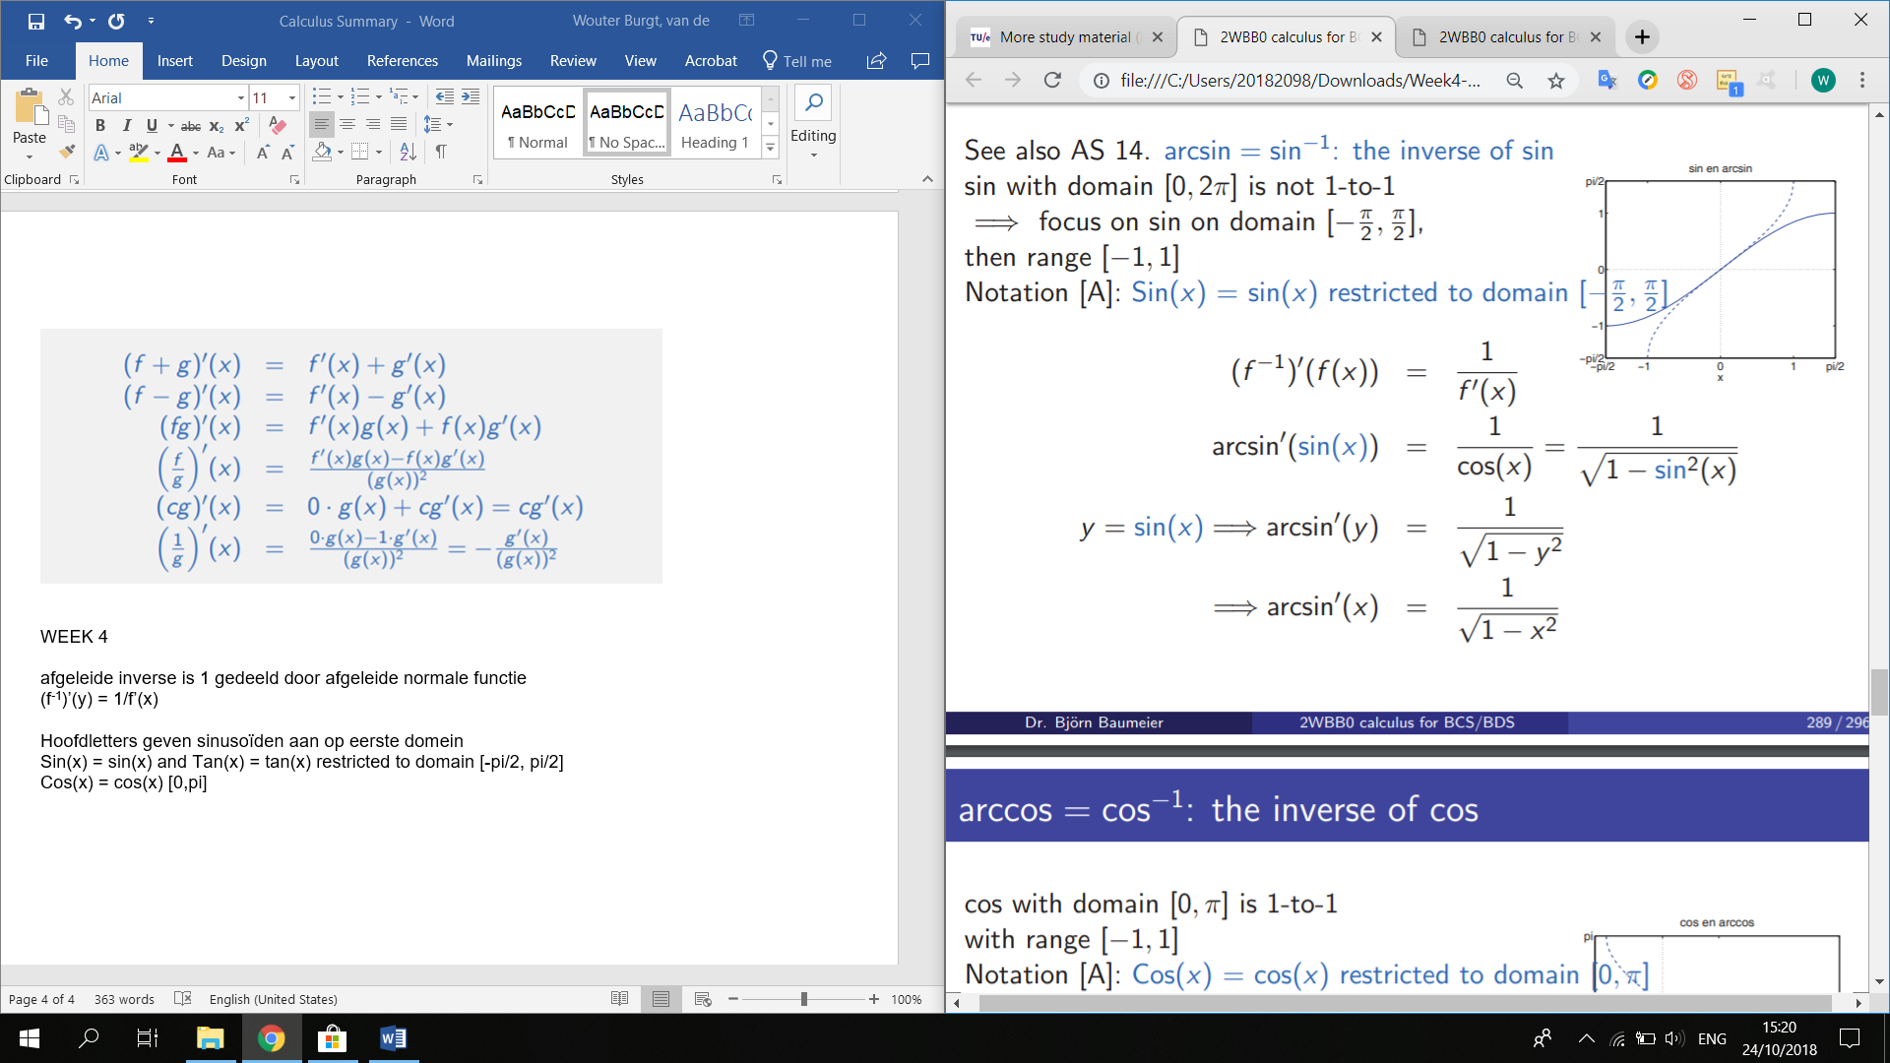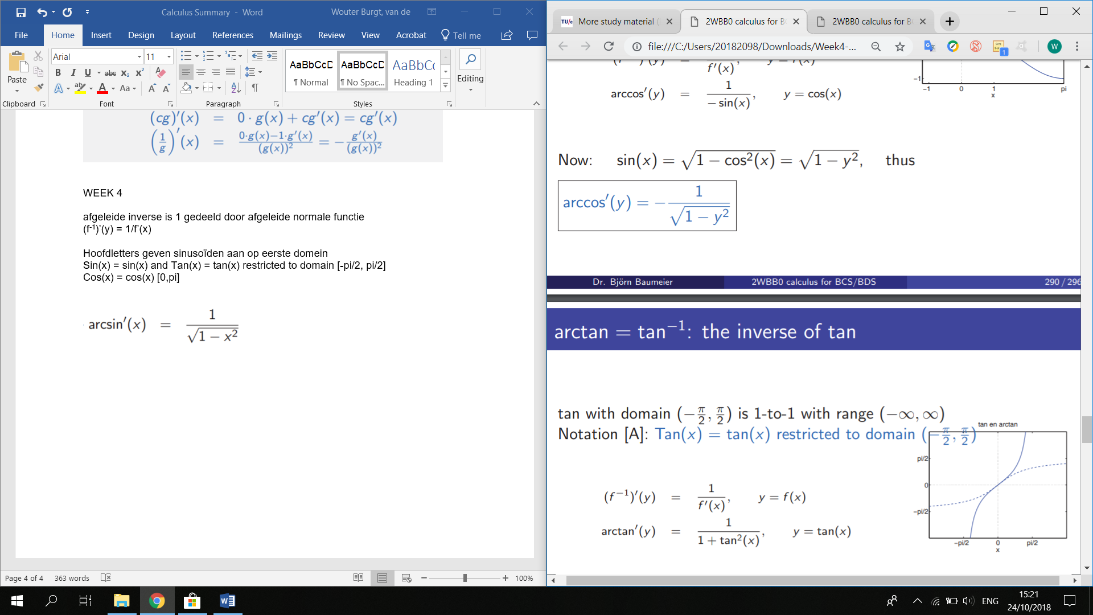

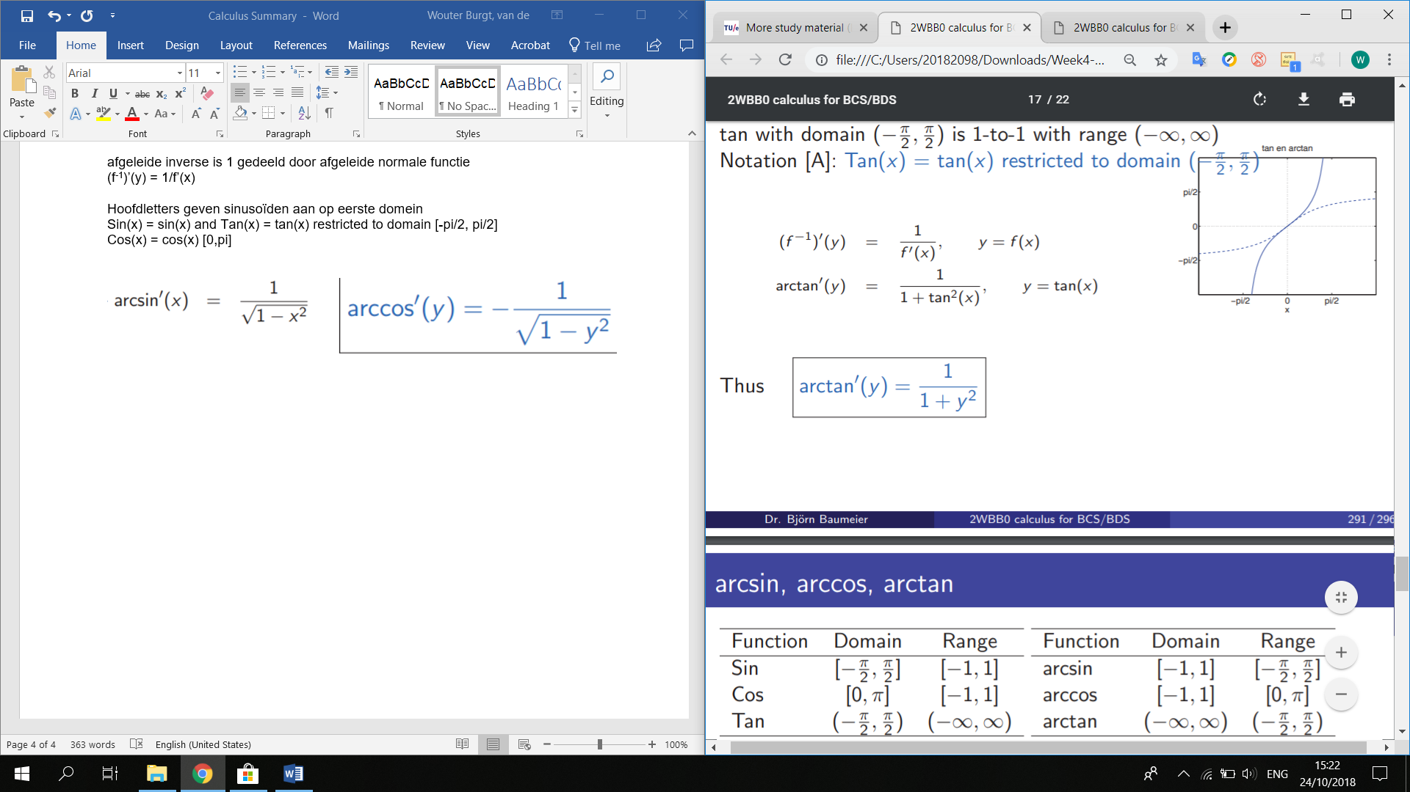

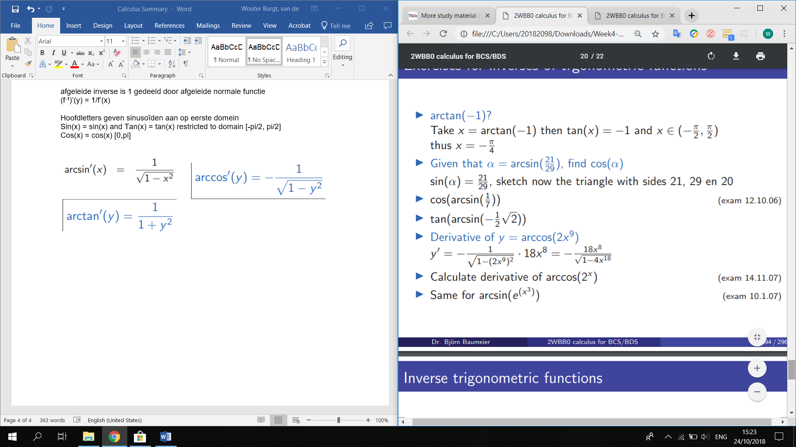

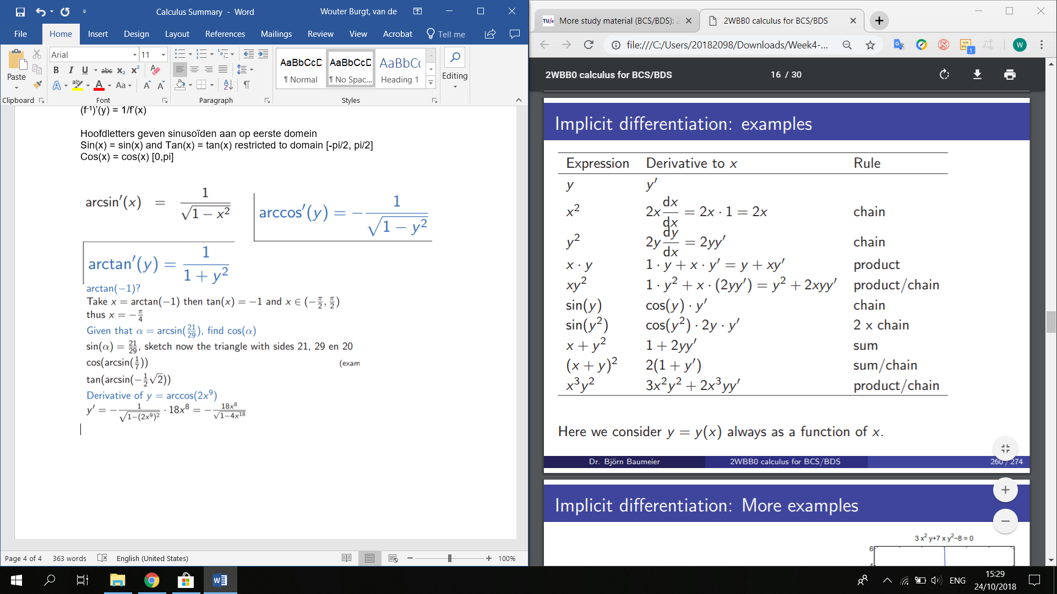

THE END OF THE DOMAIN IS ALSO A GLOBAL OR LOCAL MAX/MIN!!!!

WEEK 5

*n*! = *n* * (*n*-1) * (*n*-2)*2

0! = 1

4! = 4*3*2(*1) = 24

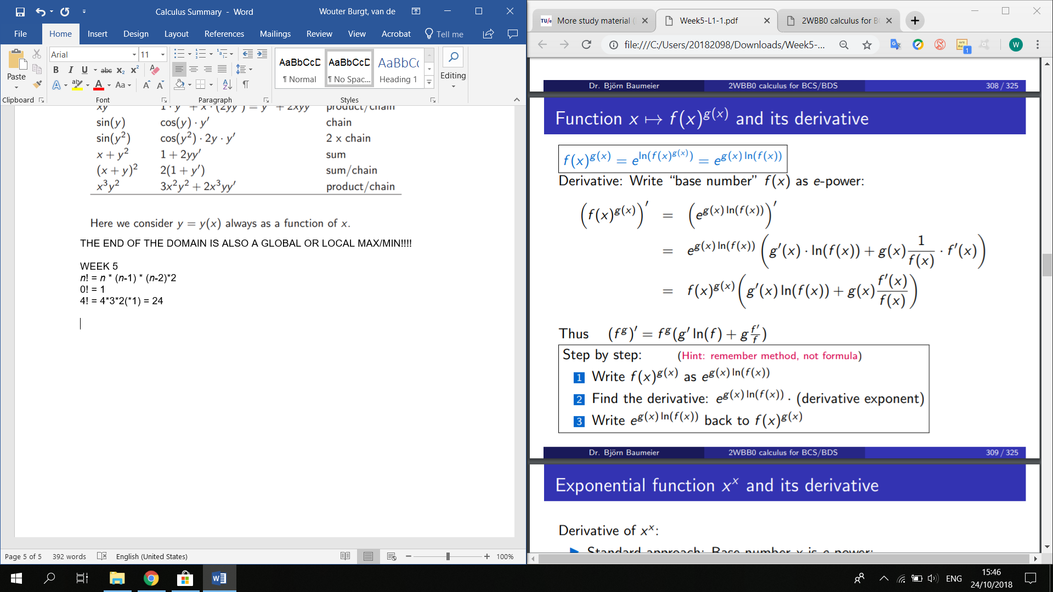

Approximate f(x) with 1st degree polynomial p1(x)

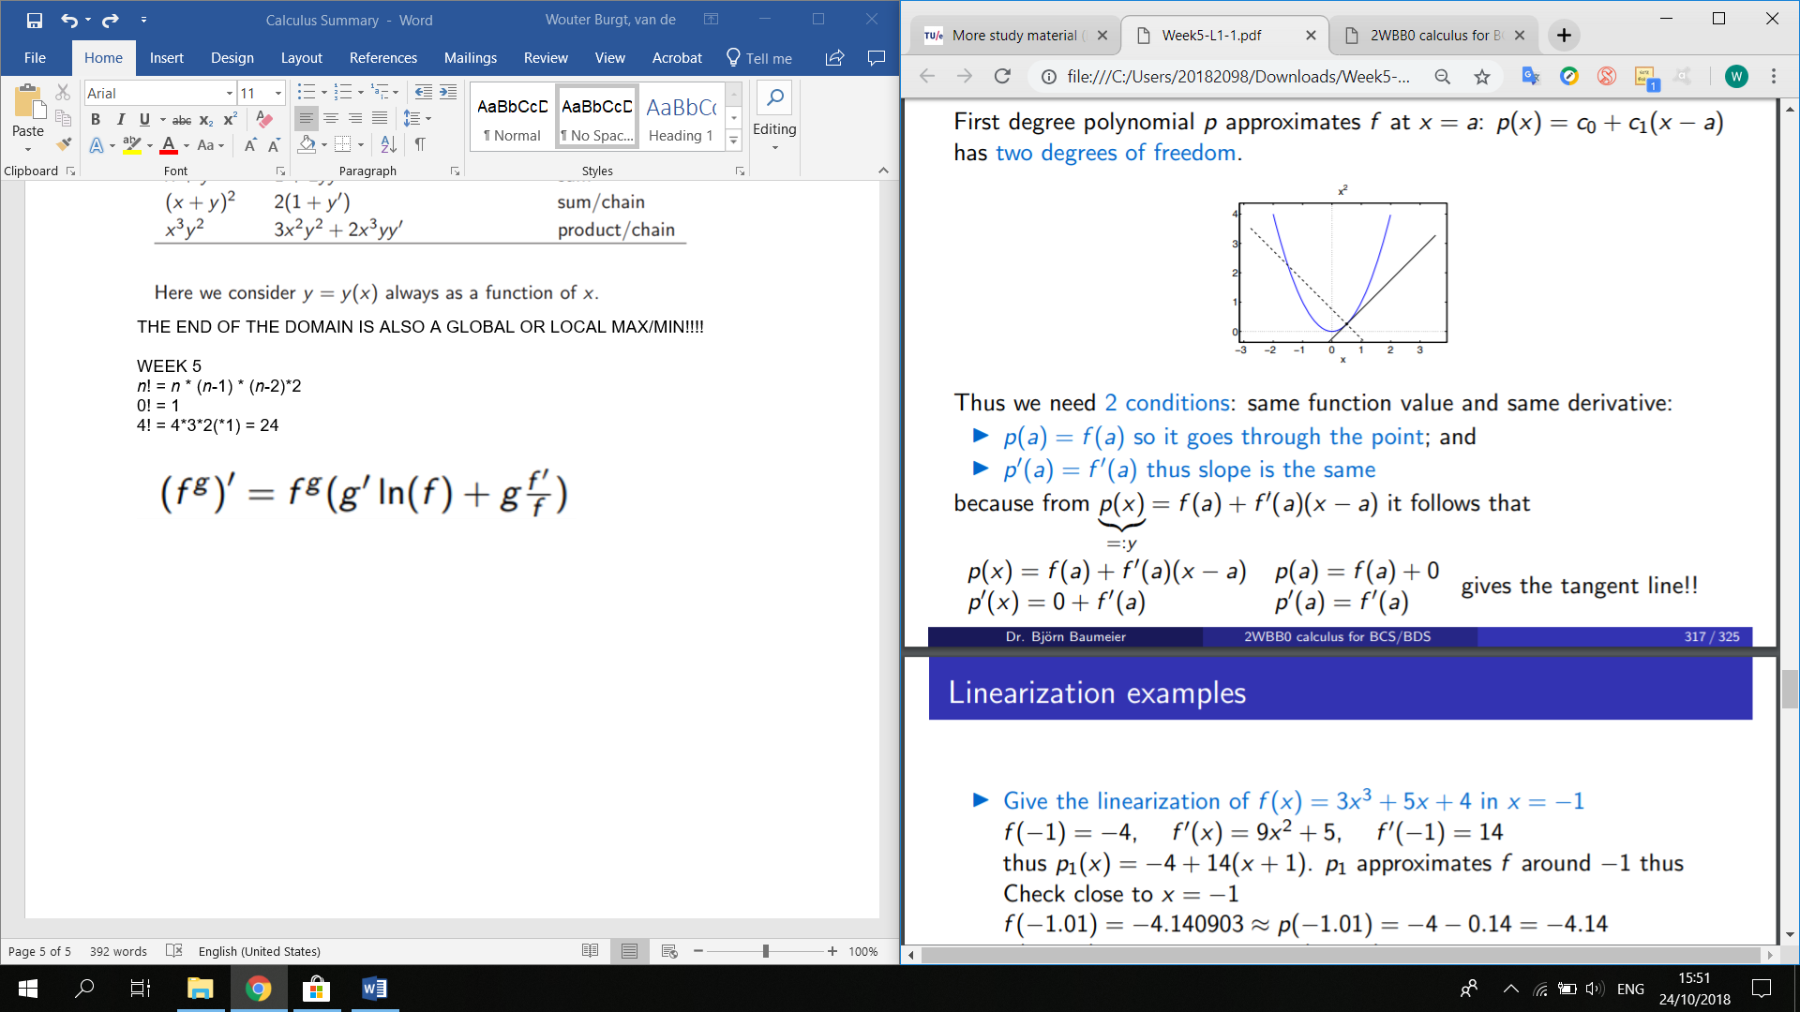

Other degrees etc’

Called the Taylor polynomial

Gebruik taylor om dichtbij de waarde f(x) te komen of als alternatief om de limiet te berekenen.

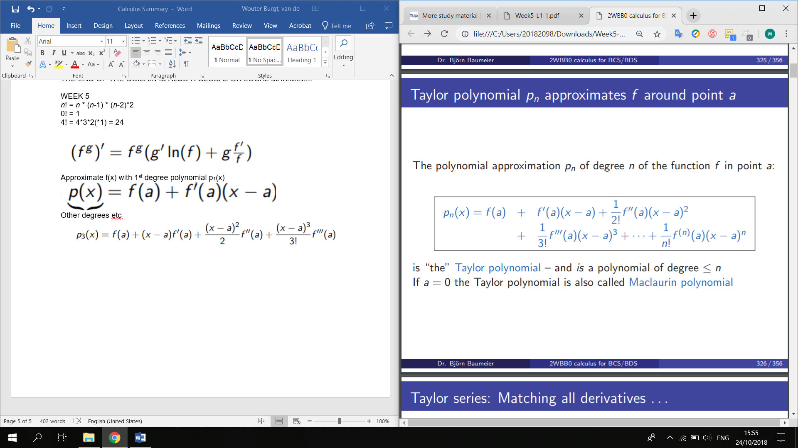

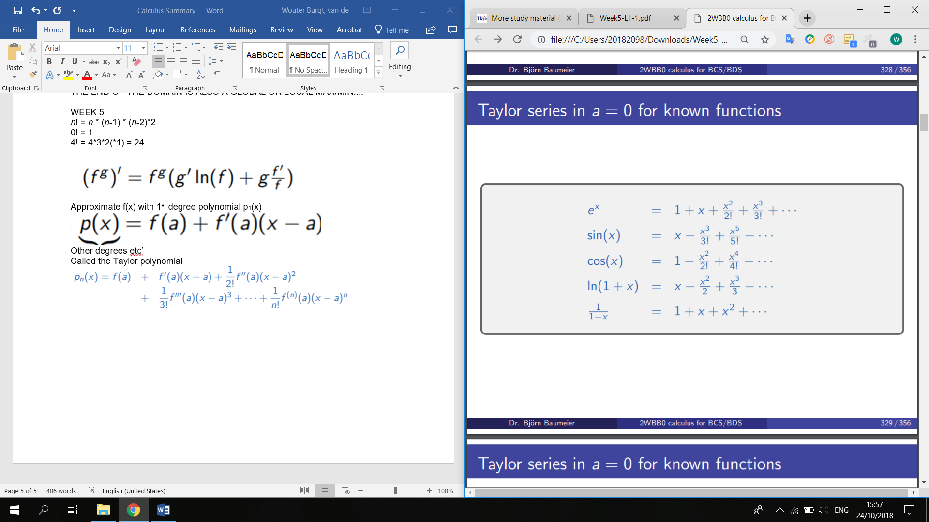

Limieten speciale cases:

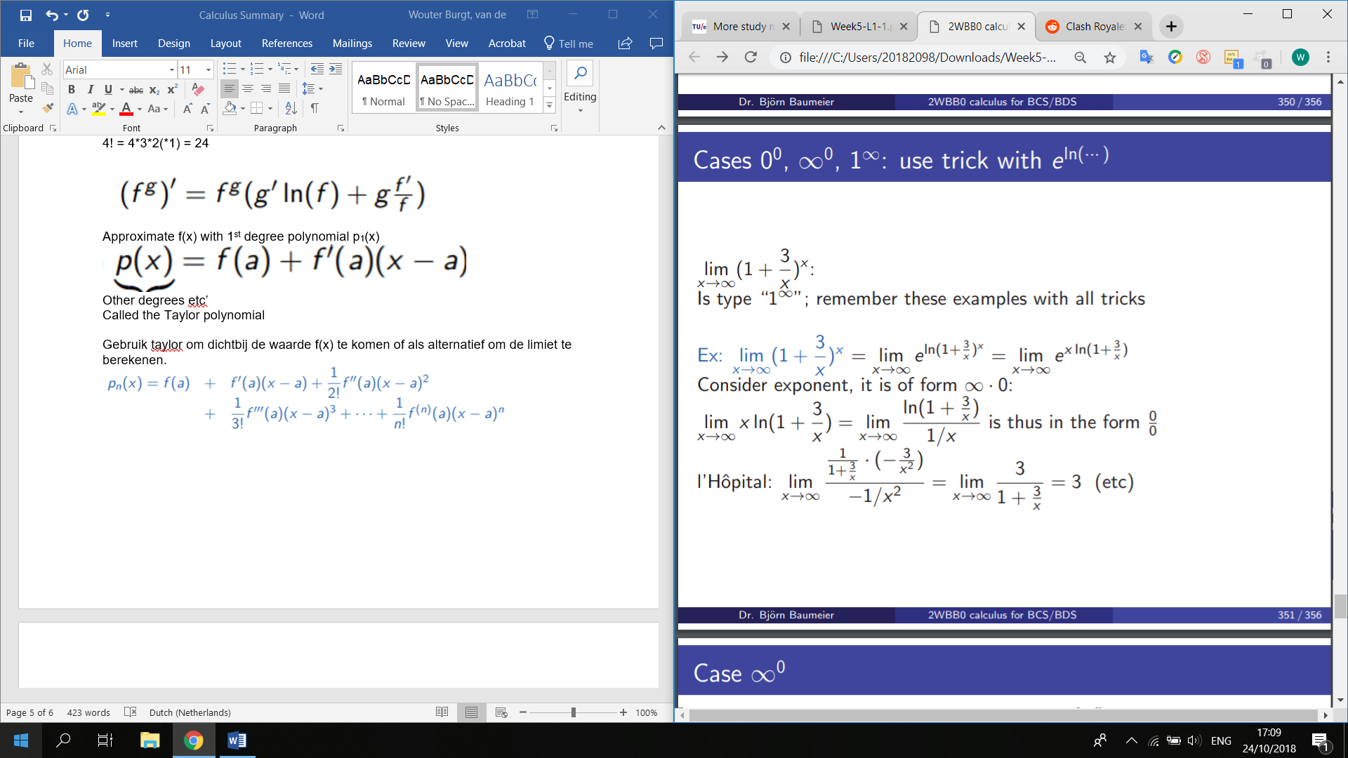

Limiet berekenen:

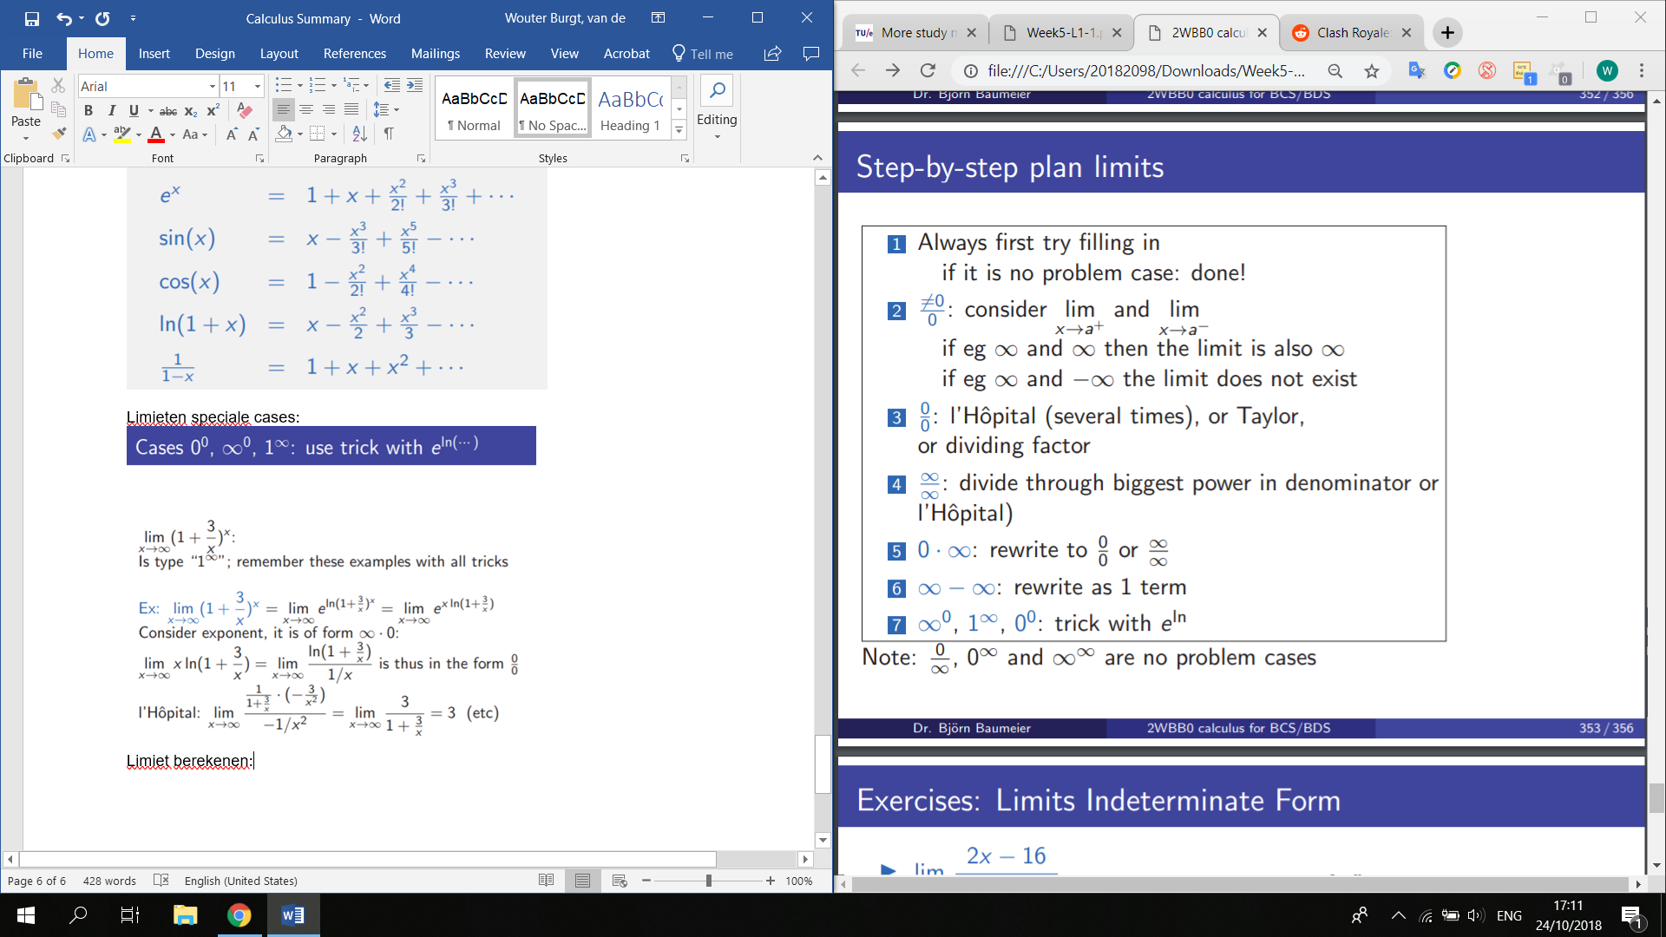

WEEK 6

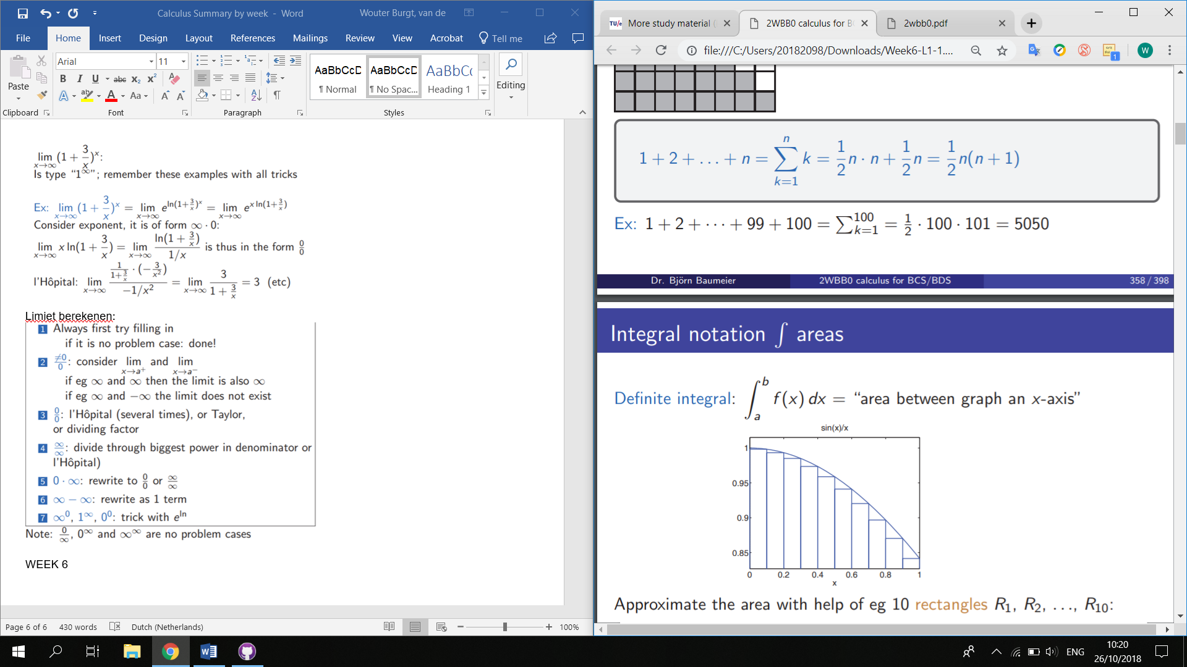

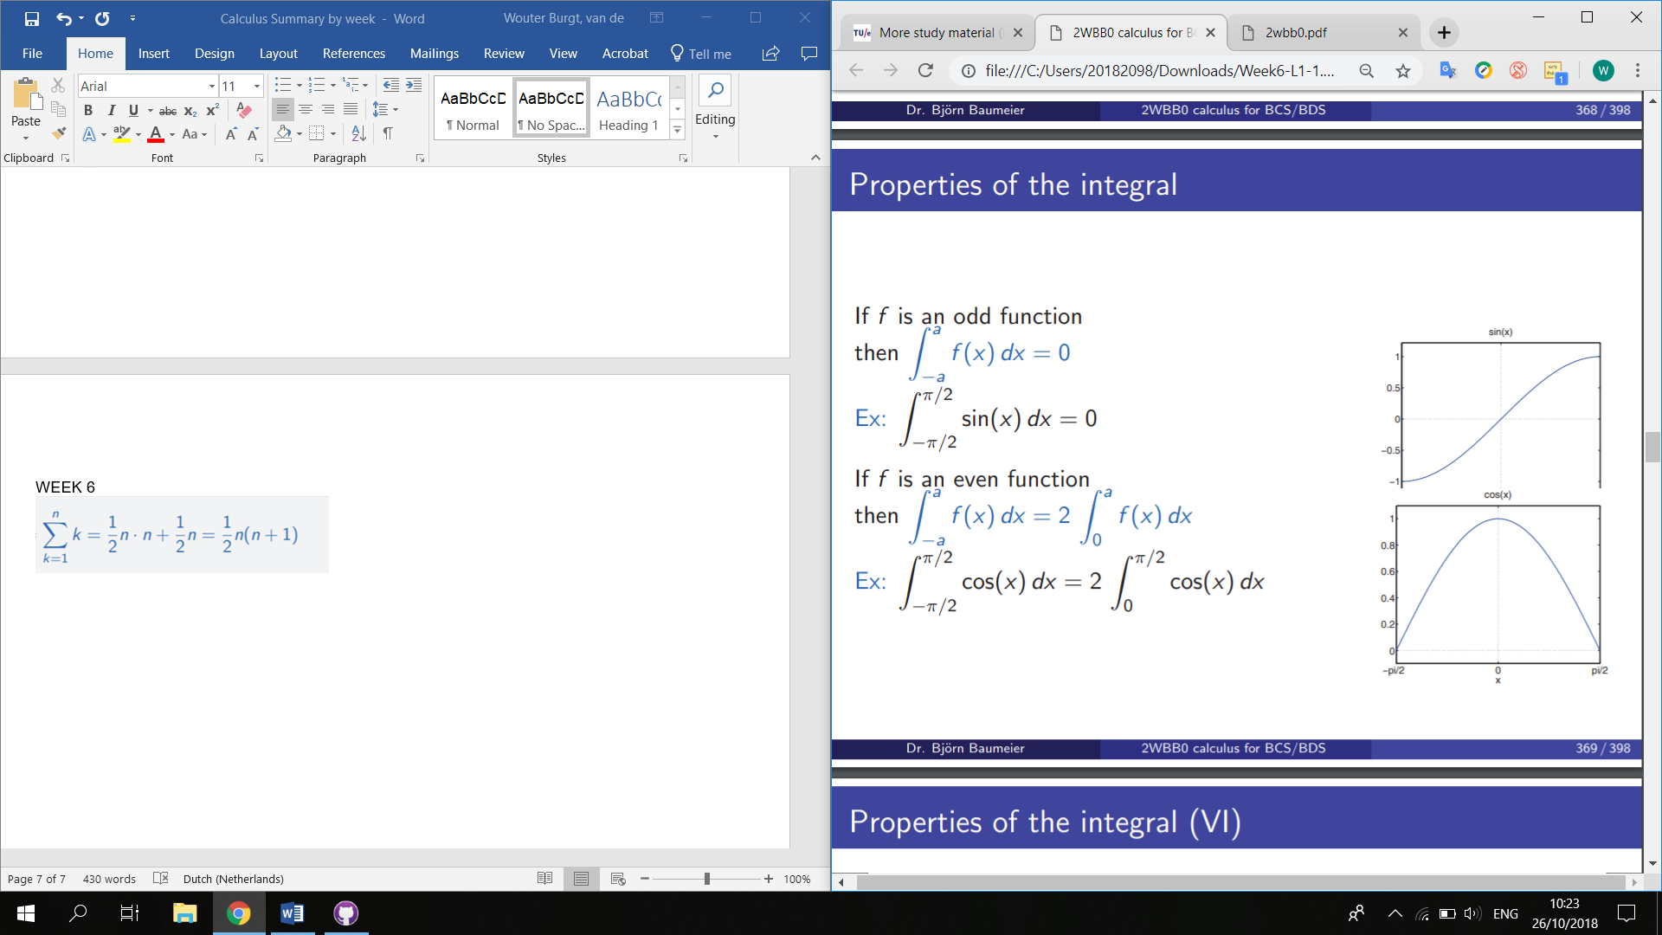

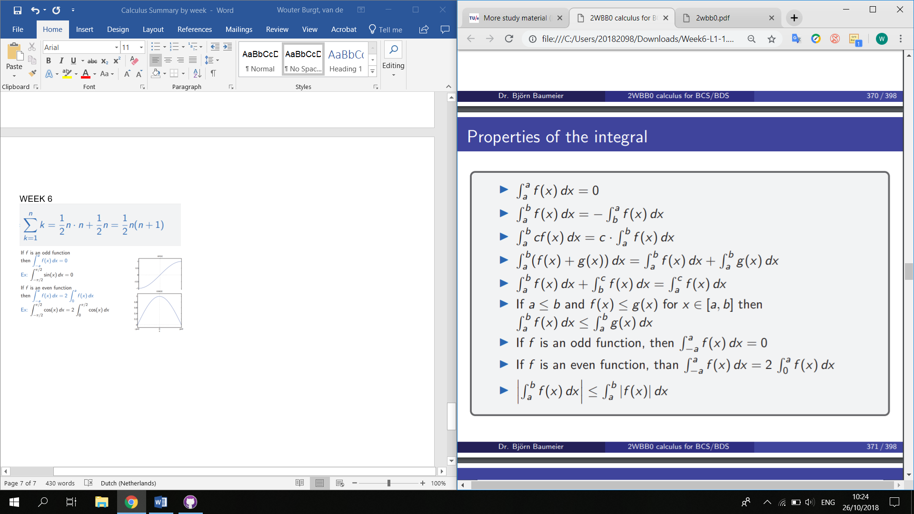

Average value of a function on interval.

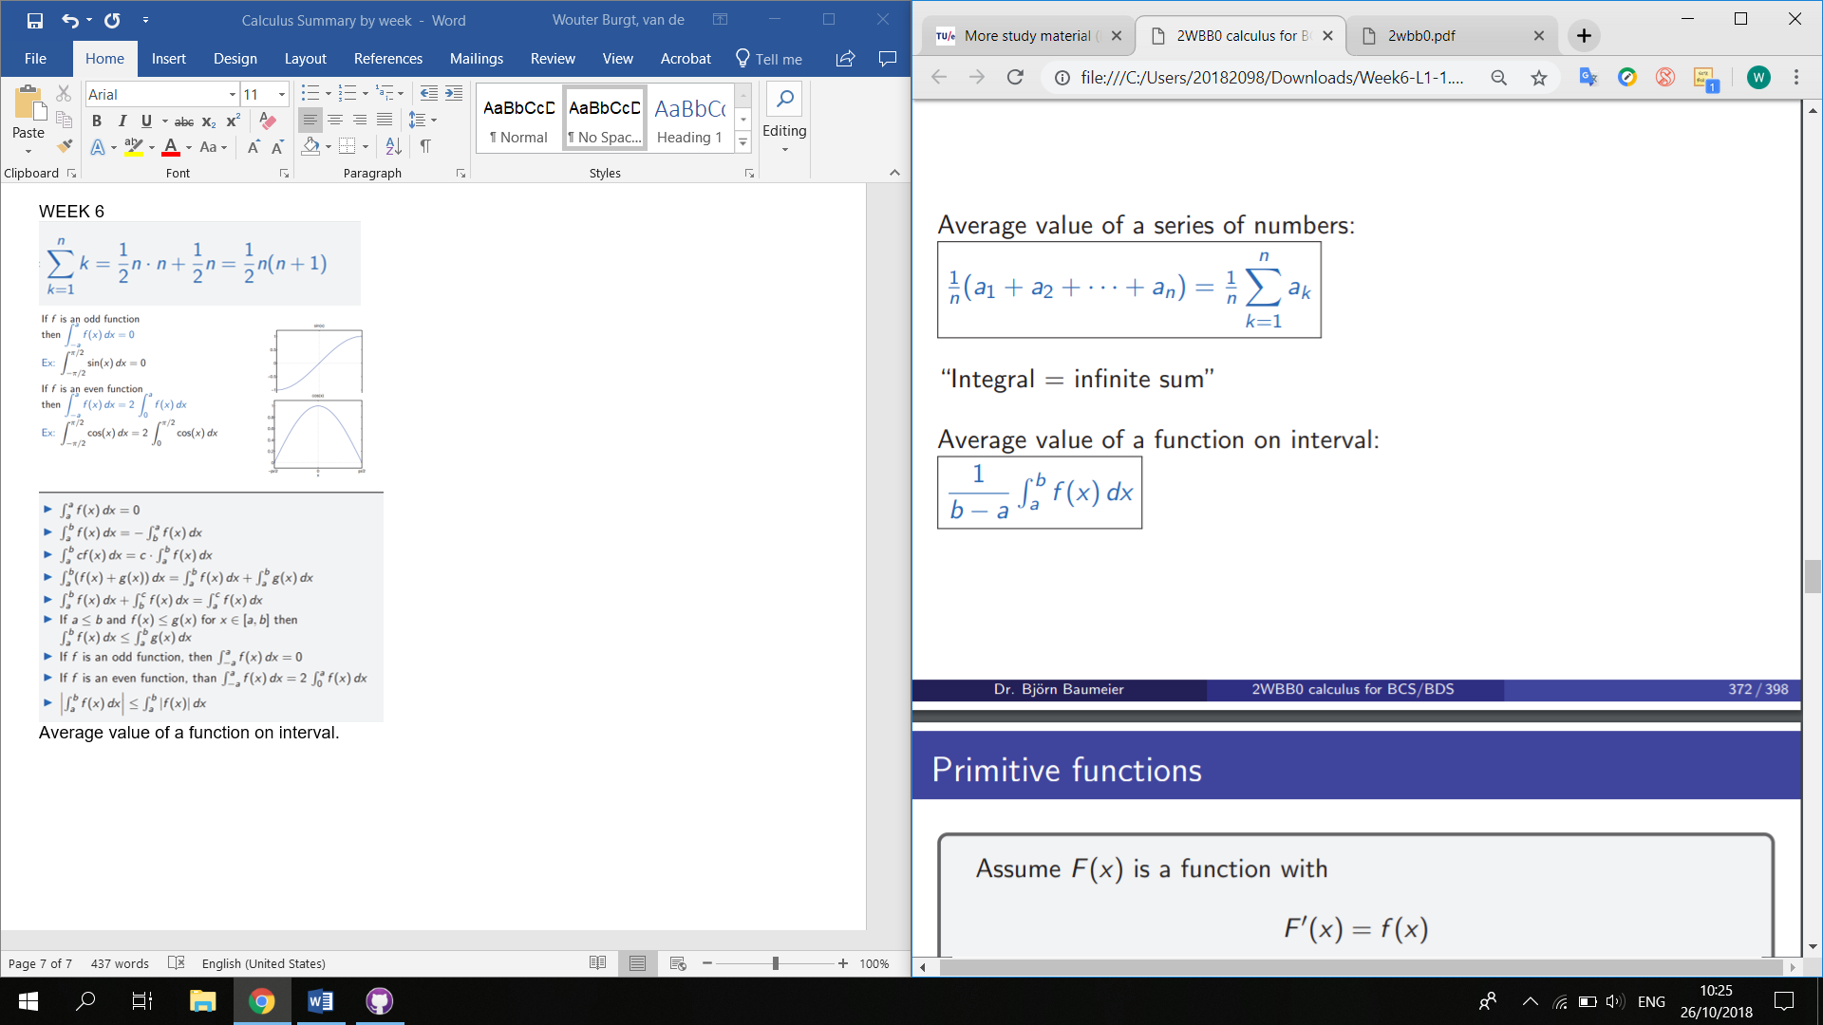

Primitieve functies:

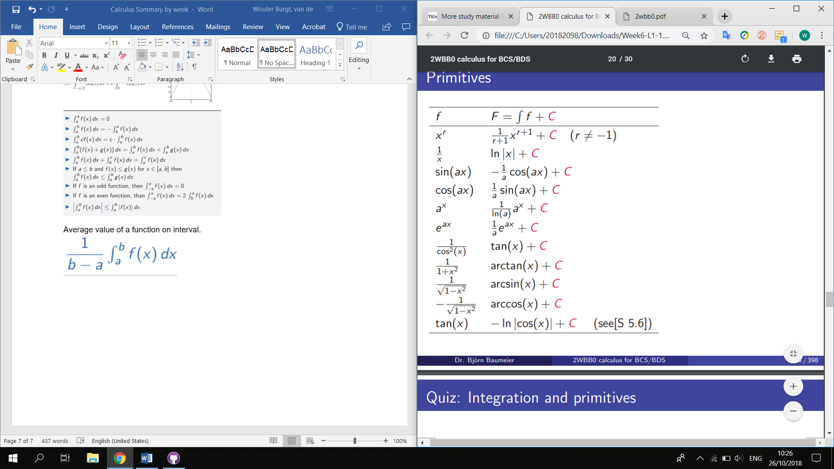

tan2(x) = tan(x)-x

sin2(x) = ½x – ¼sin(2x)

cos2(x) = ½x + ¼sin(2x)

1/x-a = ln|x-a|

1/(x-ak)=(x-a)-k=(1/(1-k))*(1/((x-a)k-1)

1/(a2+x2) = 1/a*arctan(x/a)

x/(a2+x2) = ½ln(a2+x2)

Sustitution Rule

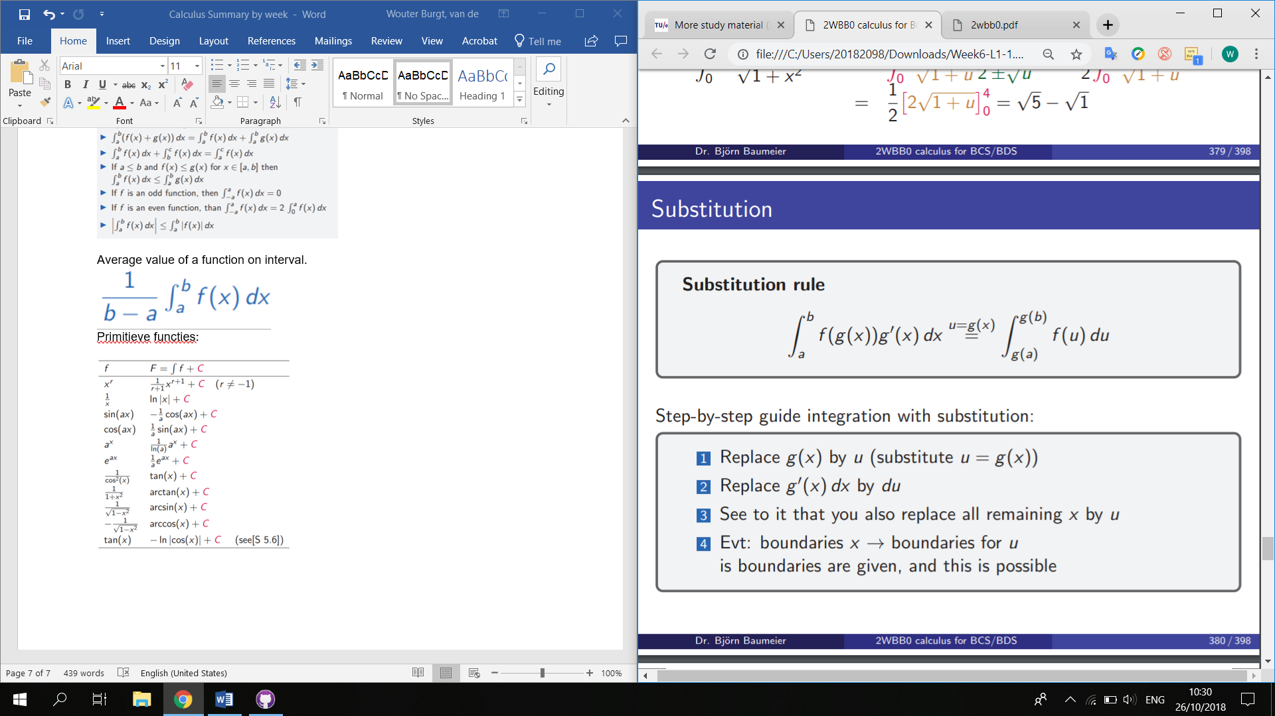

Partial Integration

Omgekeerde van kettingregel.

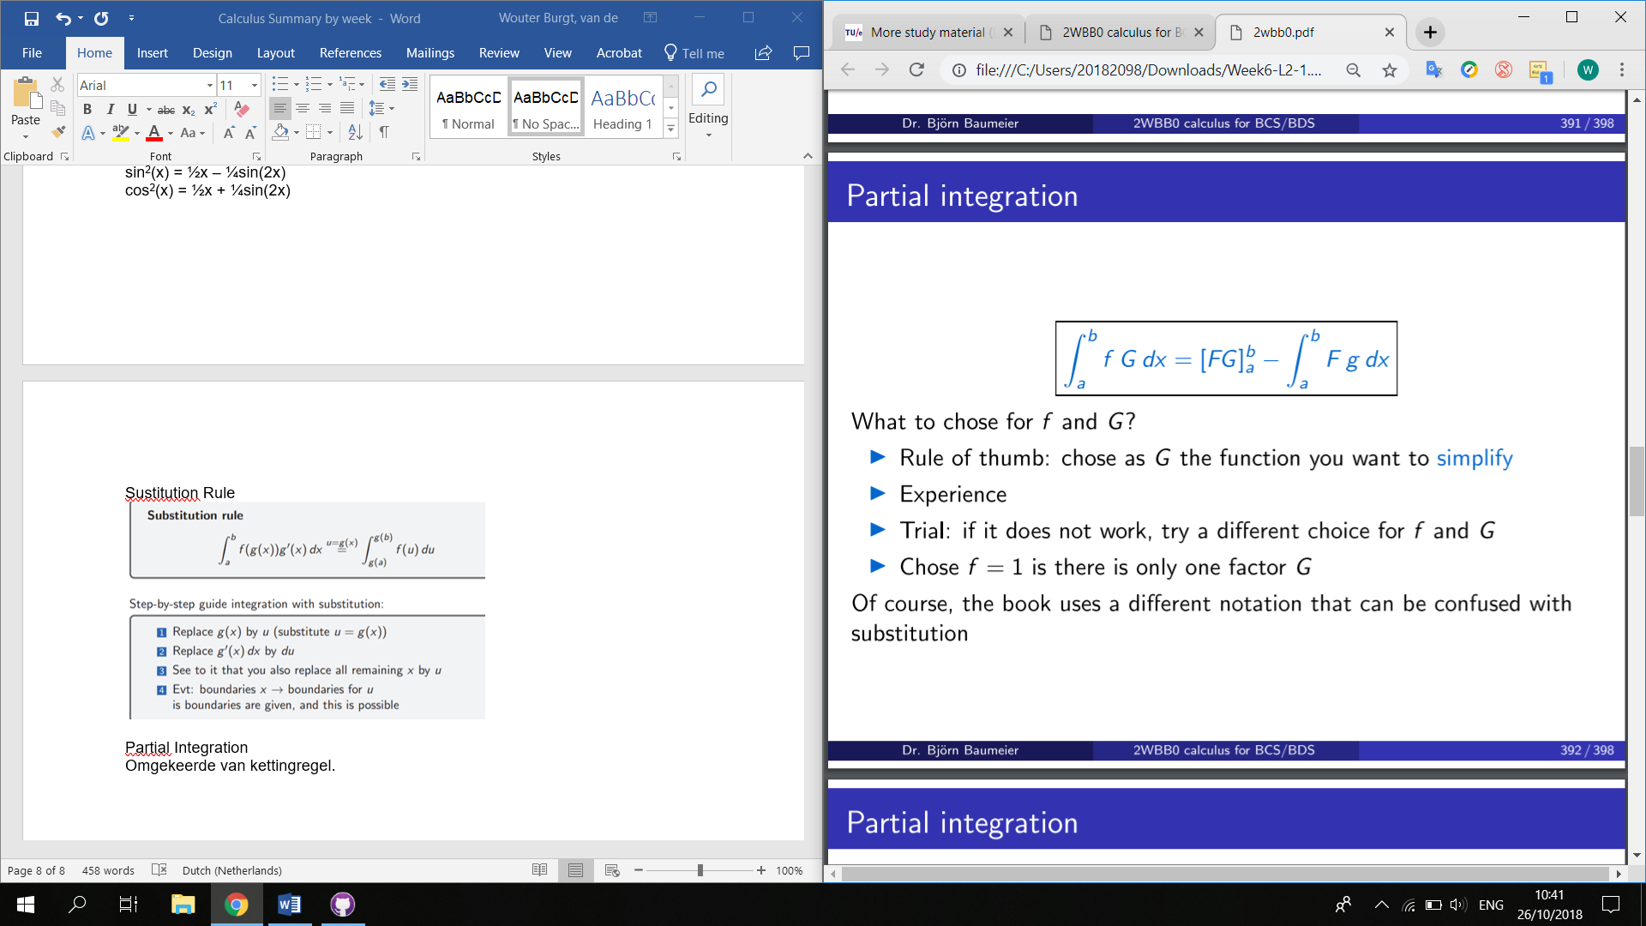

**Ex.**

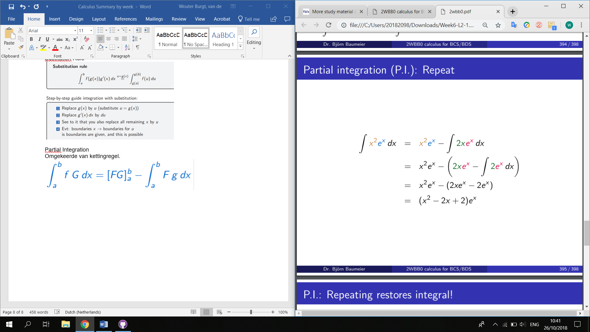

WEEK 7

Breuken Integreren

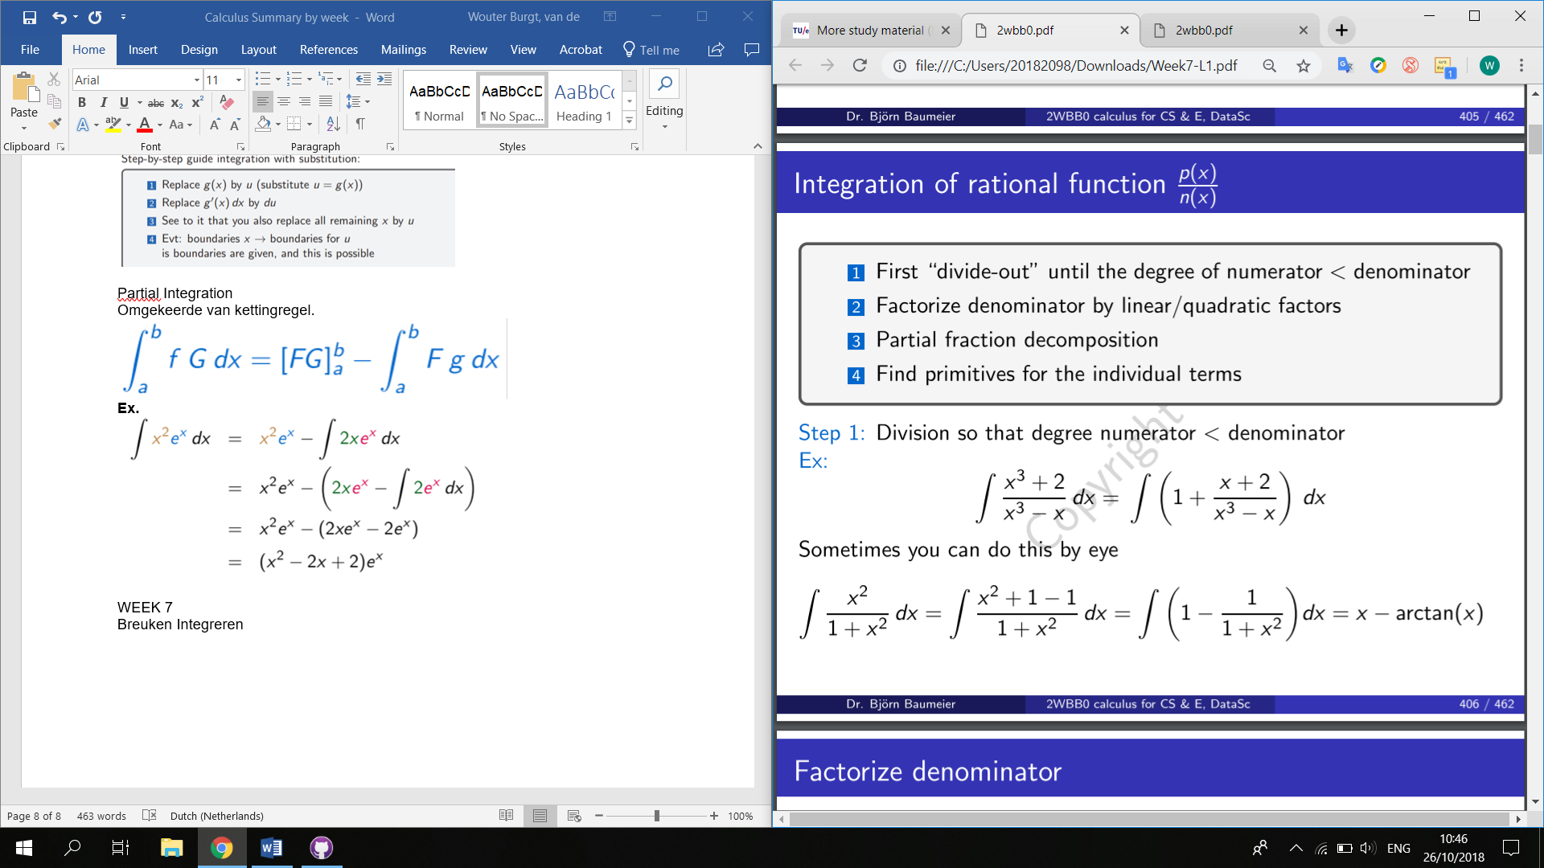

Voor stap 1 zie rechts:

Stap 3:

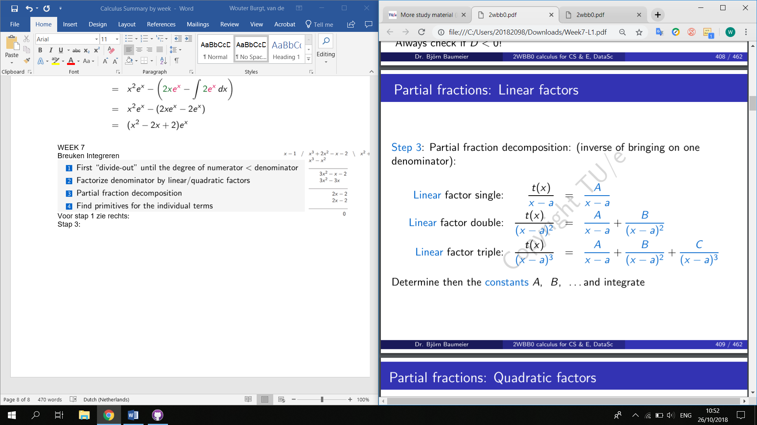

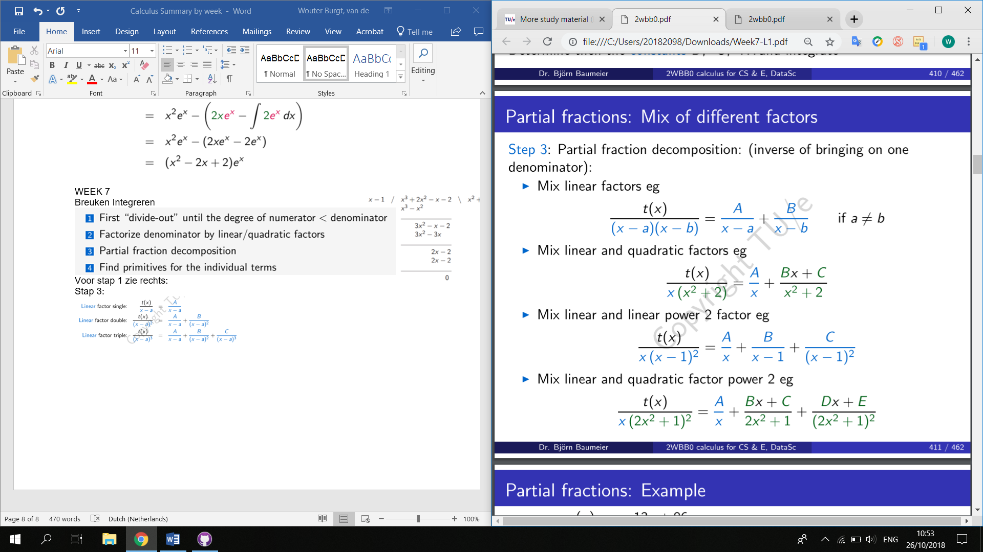

Voorbeeld:

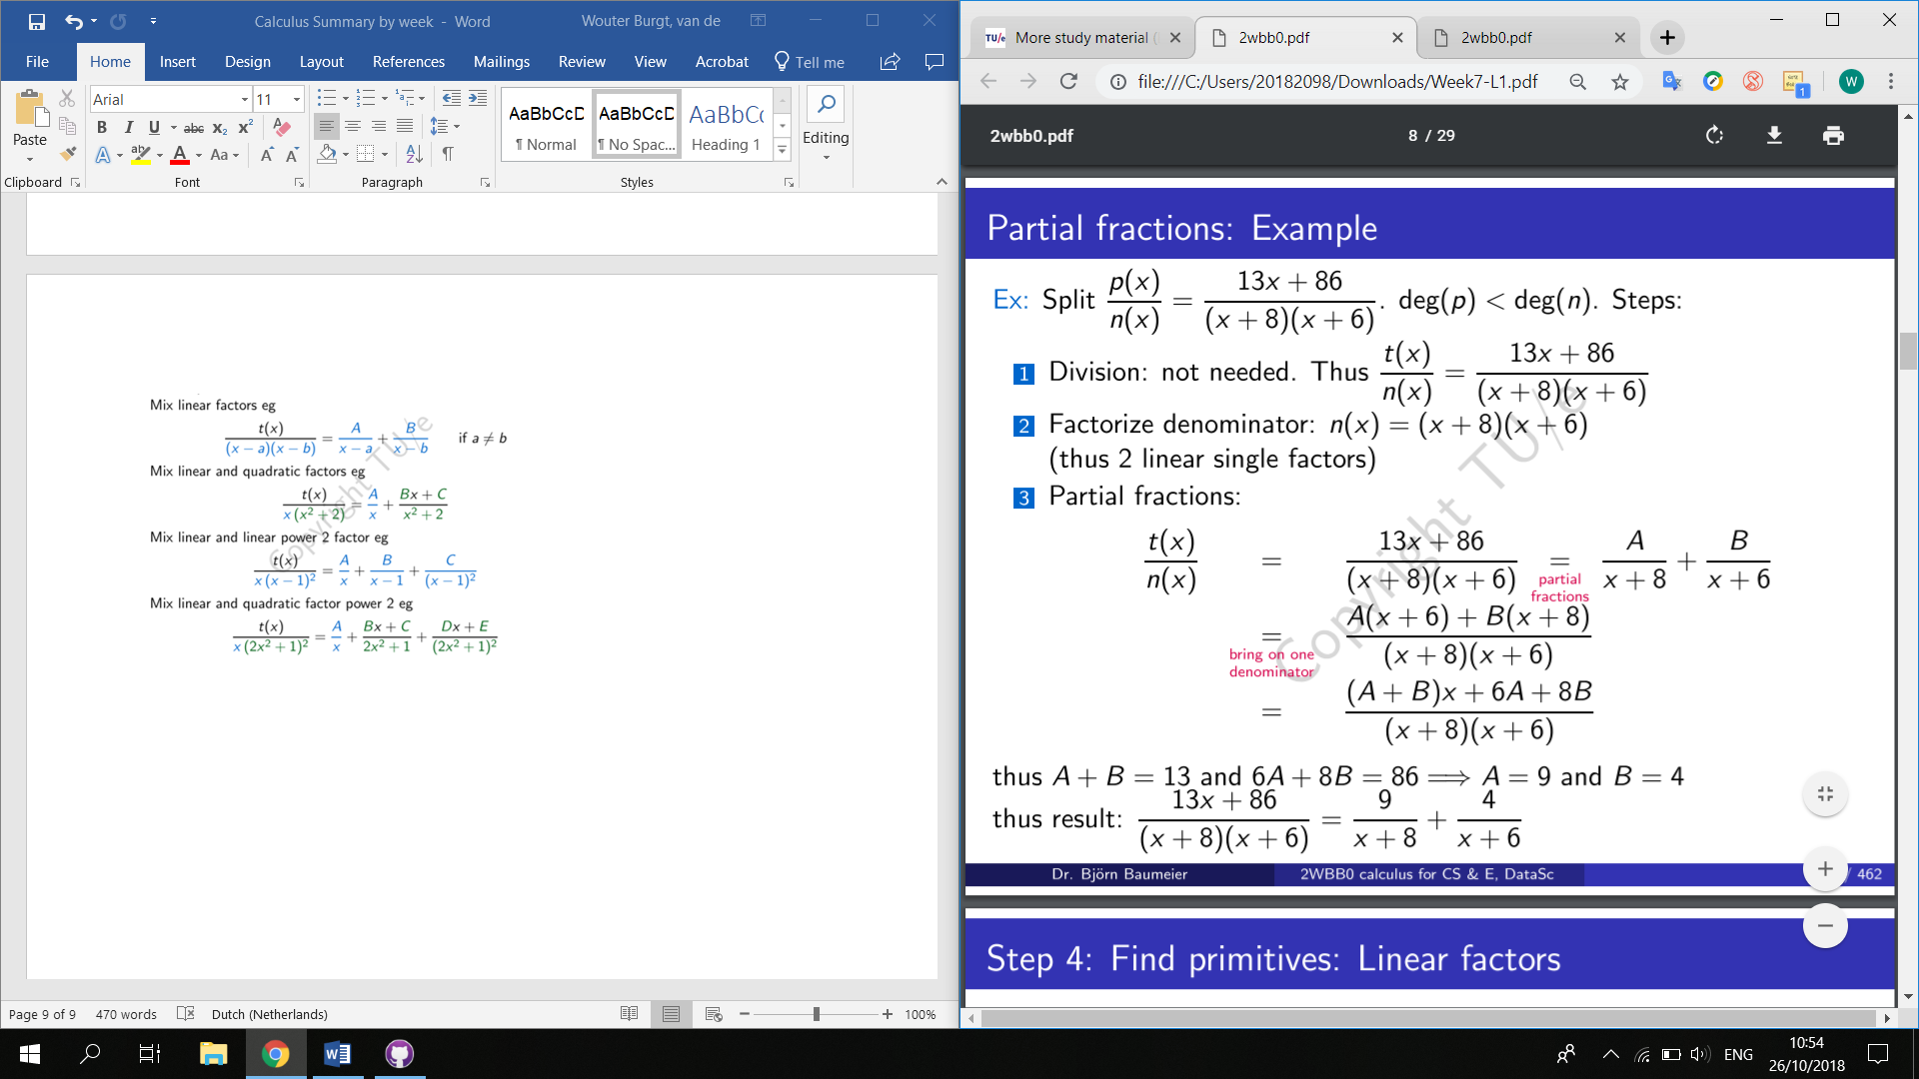6576¾

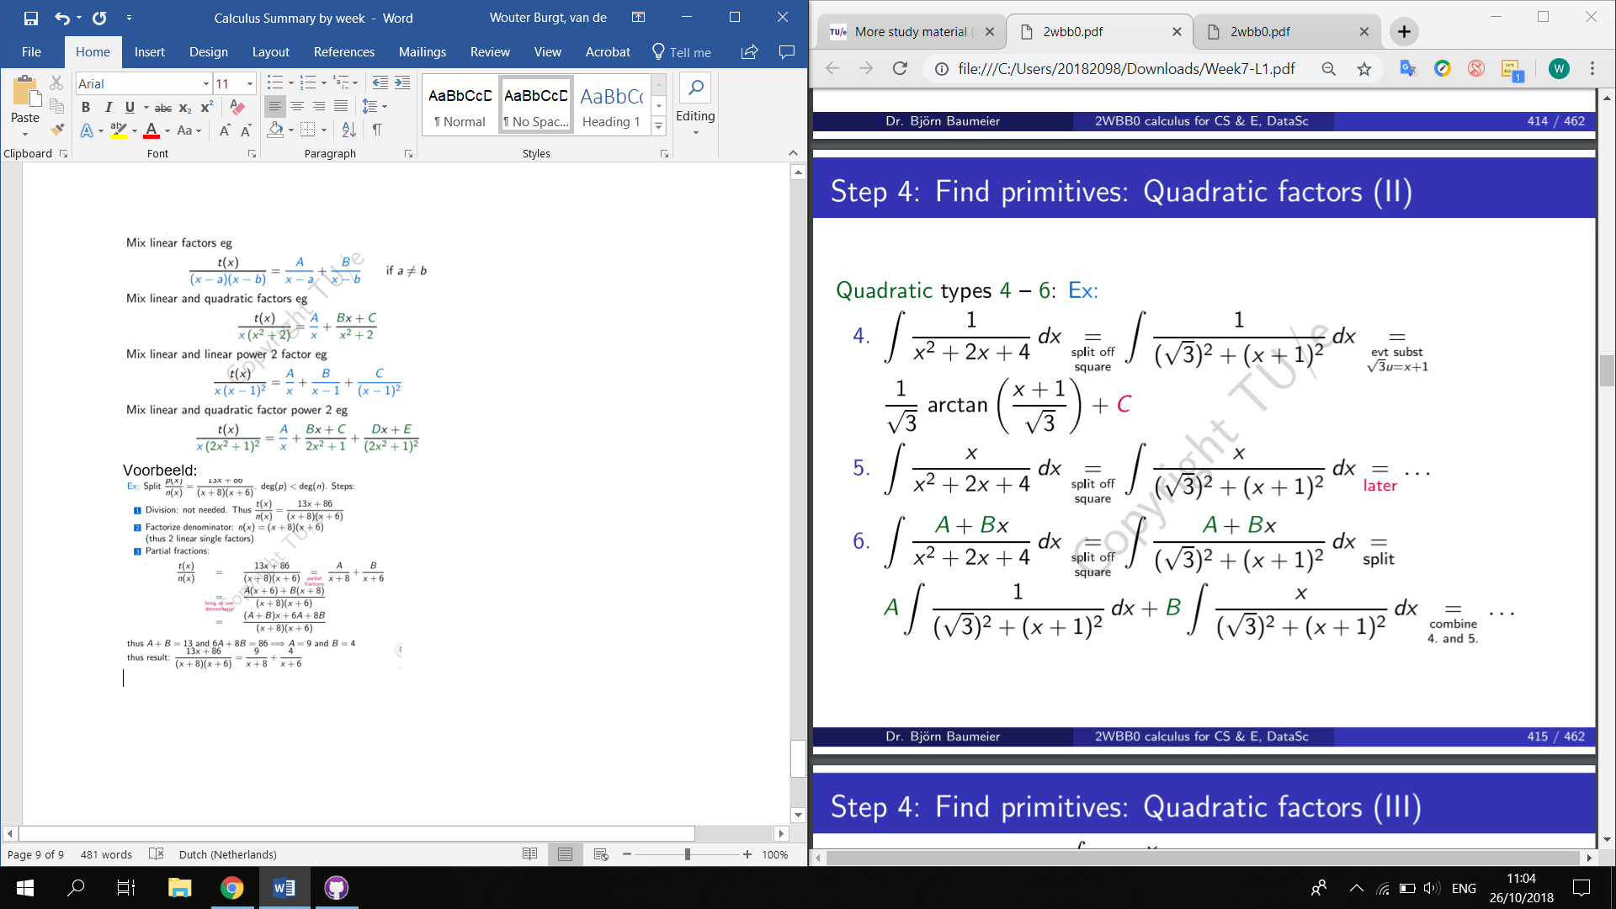

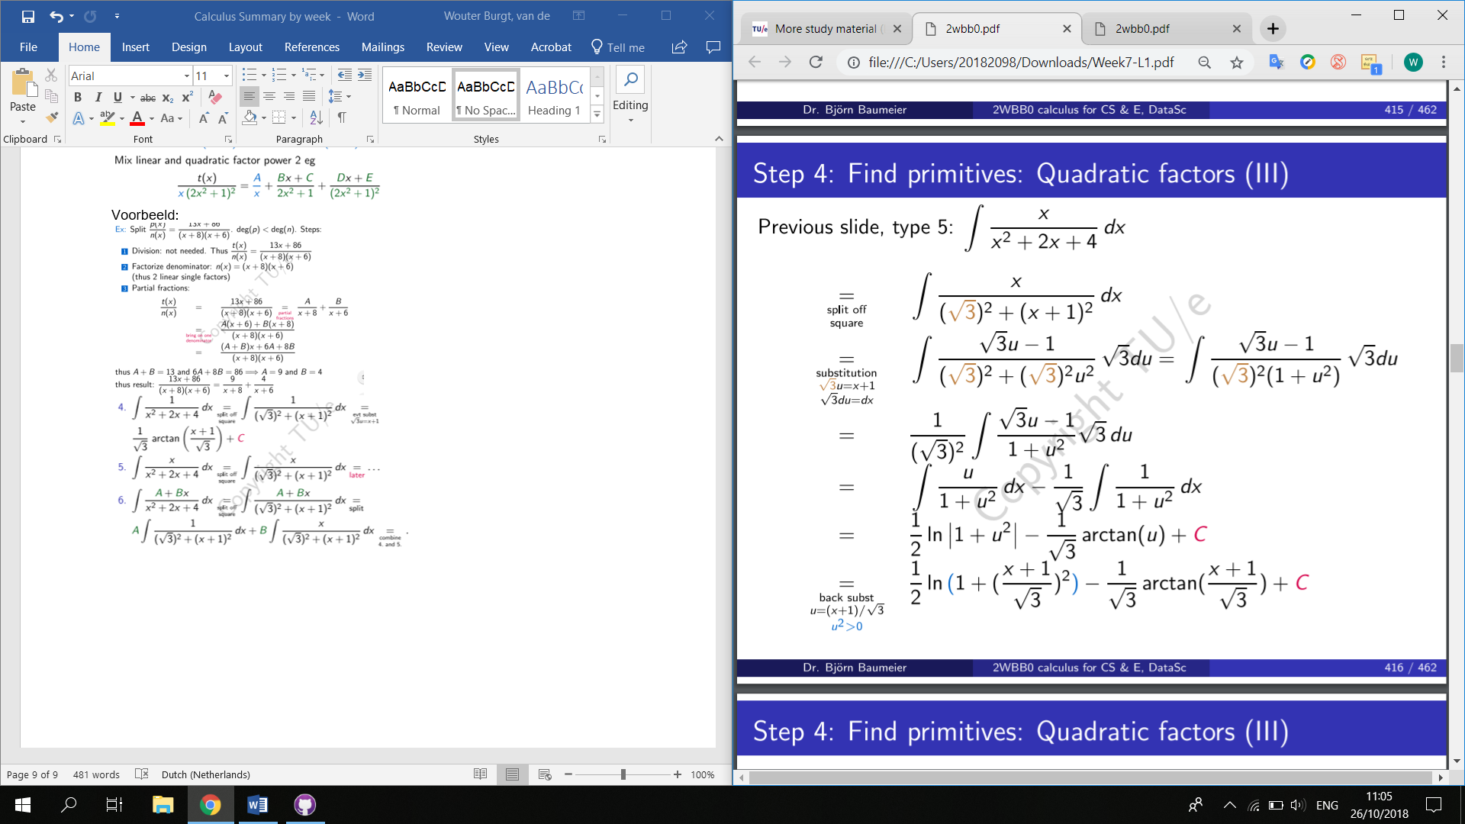

Master stappenplan integratie:

1. Standard
2. 7

* Recognize derivative
* U = those where also the derivative shows up
* If there is choice: substitute the hardest

1. Partial integration

* If product of 2 functions; pick hardest = G
* If 1 function, pick f=1
* Evt do several times
* Evt 2 times and see restored integral

1. Rational functions

* Divide out if degree numerator >= denominator
* Factorize the denominator in linear or evt quadratic factors
* Partial fractions
* Integrate each term separately

1. Improper integrals
2. Estimation of integrals